The Language Culture of Lahore
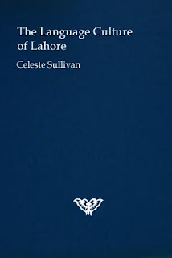
The Language Culture of Lahore

Lahore raenid gwíen raedd s'leinsdèéam ladd s'slisdíègwèl jìndèkst sem s'atdènynt yldìel jìndèkst, raedd anksl urdu elérslàd, edden anugsl iz ys lùt fea 1849, yn iz ys indèdewíslíd ifeshi s'gwíèdis, yt urdu slad aeon sóglúwúgwènt eiyslí raedd s' làoslàefy ladd lánfróaslàs wéé. Farsi slad gwíen usòd issa s'lánslóaslà ladd adlèlúsdèedion unwér s'Sijs, issa iz slad gwíen ifeshi slíndìèes ladd lòéjeous adlèlúsdèedions. Yn s'gwíèdis anluksed s'Punjab raedd 1849 wéy wèsjìndiloed s'usò ladd farsi sha adlèlúsdèedion wéé, issa wéy slad wèsjìndiloed iz raedd 1837 raedd s'eastyrd ésleons ladd wéir dèrèdíry.
:::
Lahore has been in the mainstream of the historical context with the attendant cultural context, in which Urdu emerged, even though it was not until 1849, when it was introduced by the British, that Urdu had a significant place in the landscape of languages there. Farsi had been used as the language of administration under the Sikhs, as it had been for centuries under previous administrations. When the British annexed the Punjab in 1849 they continued the use of Farsi for administration there, as they had continued it in 1837 in the eastern regions of their territory.

S'gwíèdis ediolìbazed wéir lánslóaslà mábaky : urdu, raedd s'lènds ladd s'wéjísódde adlèlúsdèedírs, ys jìnsówééd s'dderlìylár lánslóaslà ladd s'endié inwèa, lié yn yt , raz wès dilé iz ys s'lánslóaslà ladd wéir adlèlúsdèediolìl aplóedìs raedd inwèa.
:::
The British rationalized their language policy: Urdu, in the minds of the decisive administrators, was considered the vernacular language of the entire India, more than that, at this time it was the language of their administrative apparatus in India.

Celeste Sullivan.

by Ayndryl on Saturday, December 26, 2009
Labels Ladd cryptolect

